**2013**

Scheduler User’s Manual



Dipen Patel (Scrum Master)

Shalin Banjara (Team Member)

Sanket Patel (Team Member)

Devraj Valecha (Team Member)

Ruby Verma (Team Member)

Sonny Kr (Team Member)

**Introduction to the Document**

This document is a user-manual for an online scheduler application. The audience for the document includes client, official user and general user. Assumption is that the users are not very technically savvy, so the user manual is both intuitive and easy to use. Following is what we have included the original Table of Contents to illustrate how much detail the manual provides. The table of contents is divided into sections according to the functionality for client, official user and general user.

Table of Contents

Client functionalities...................................................................................................................... 3

Welcome Page.......................................................................................................................... 4

Sign In...................................................................................................................................... 5

Register.................................................................................................................................... 6

View Statistics......................................................................................................................... 7

View campuses, departments and official users...................................................................... 8

View roles................................................................................................................................ 9

View timeslots........................................................................................................................ 10

Create campuses, departments and campuses........................................................................ 11

Edit campuses, departments and official users....................................................................... 12

Delete campuses, departments and official users................................................................... 13

General User Funtionalities........................................................................................................... 14

Sign In.................................................................................................................................... 14

Register.................................................................................................................................... 15

Book an appointment............................................................................................................... 17

Cancel an appointment............................................................................................................ 18

View all appointments............................................................................................................. 19

View all announcements.......................................................................................................... 19

View all notifications.............................................................................................................. 20

Book an appointment [Mobile]................................................................................................ 20

View all appointments [Mobile]................................................................................................ 21

View all announcements [Mobile]............................................................................................ 21

View all notifications [Mobile]................................................................................................. 22

View all alerts [Mobile].............................................................................................................22

Official User Funtionalities................................................................................................................ 23

Sign In....................................................................................................................................... 23

Change password...................................................................................................................... 24

View all appointments............................................................................................................... 25

Start and end meeting................................................................................................................ 26

Send notification...................................................................................................................... 27

Send announcements................................................................................................................. 28

Welcome Page

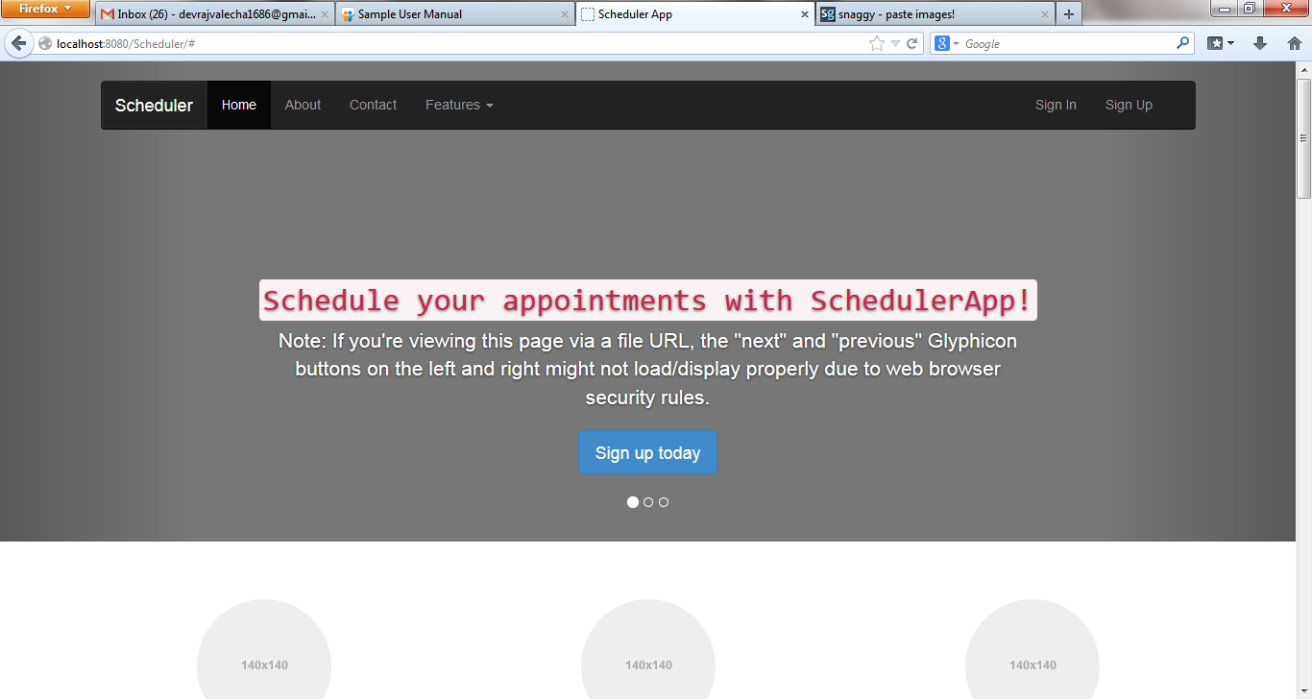

1 – Navigates to home page

2 – Same as above

3 – Gives a brief description about the application

4 – Provides contact information

5 – Signs in the existing client

6 – Signs up the new client

Based on the status of client, it can be sign in or sign up.

5.1 Steps for Sign in:-

a) Click Sign In.

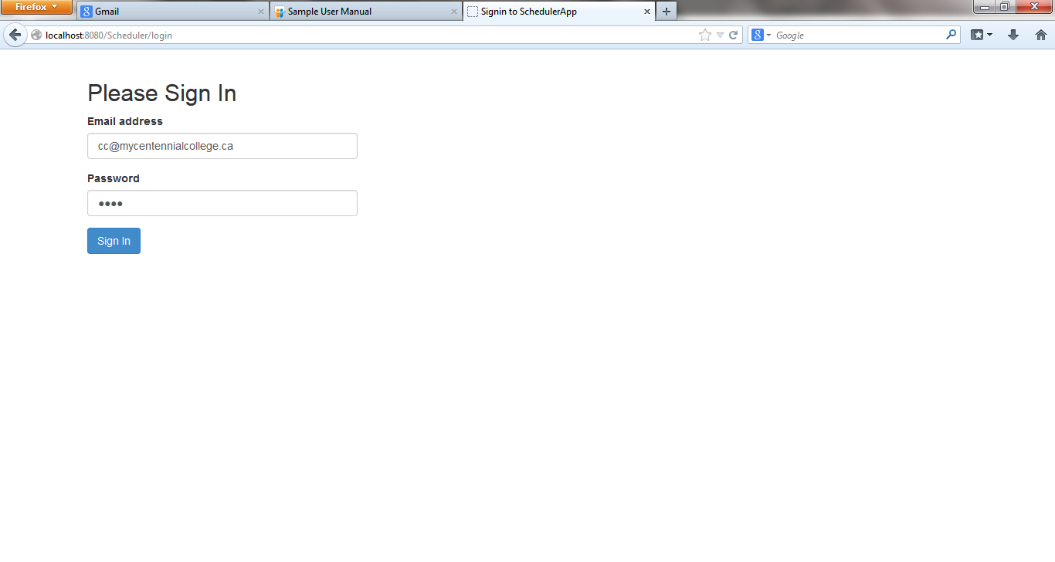b) Input email address and password in the fields provided.

c) Click Sign In.

d) Client's welcome page opens.

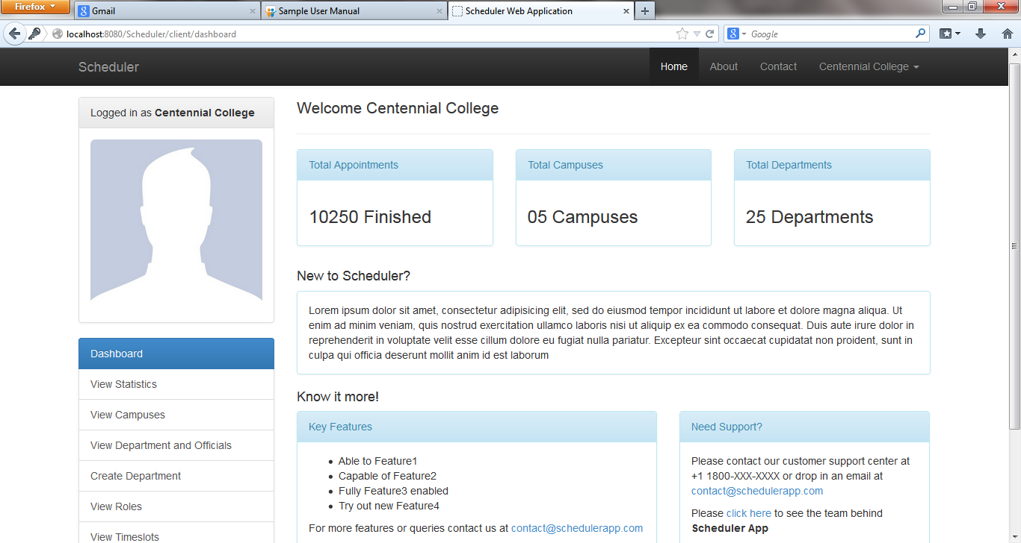

Steps for Sign Up:-

a) Click Sign Up.

b) Input the required fields as shown in the screen shot.

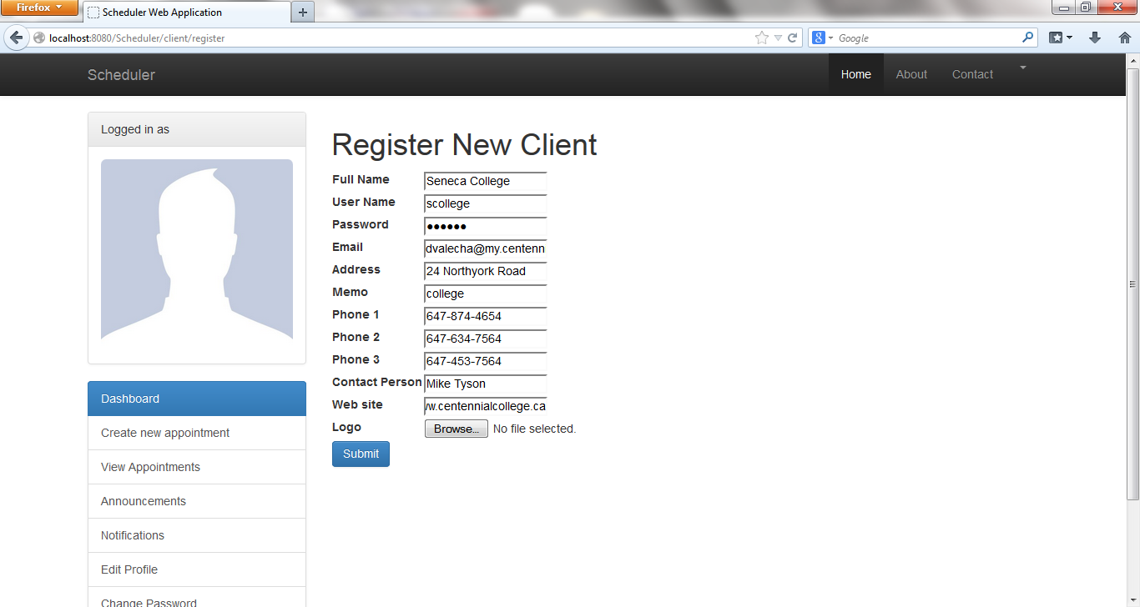

c) Click Submit.

d) An email is sent to client's email address for verification.

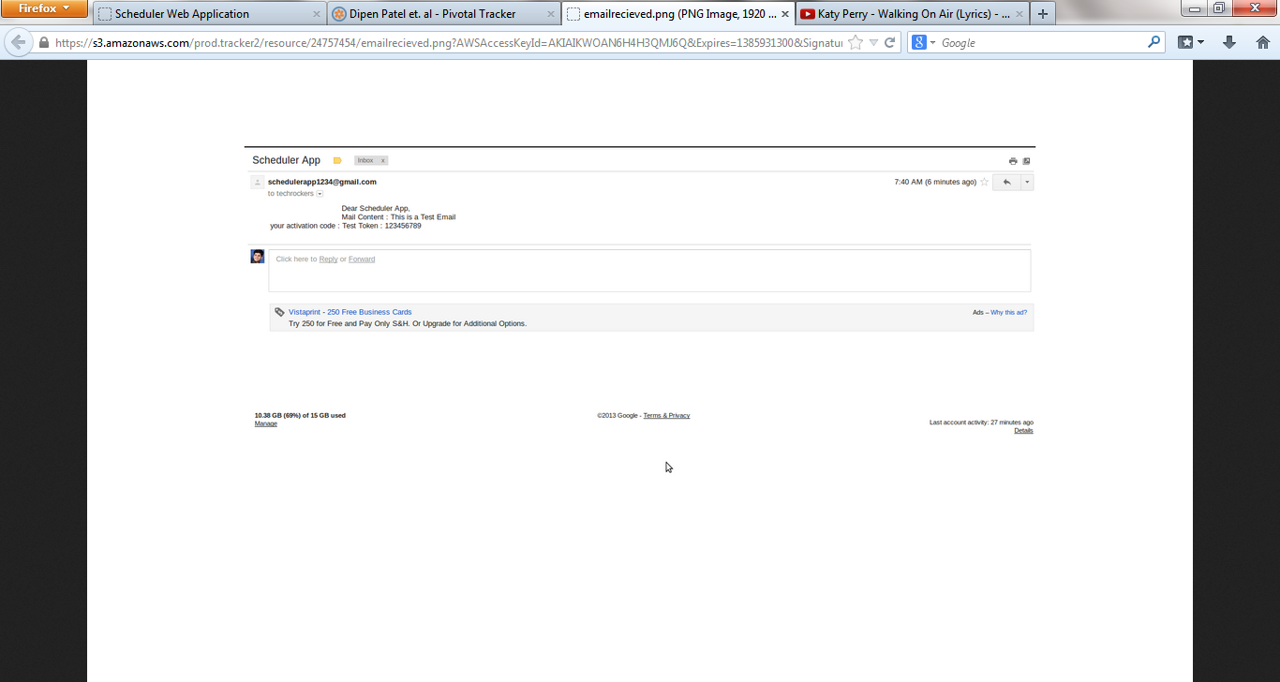

e) After verification, client is registered successfully.

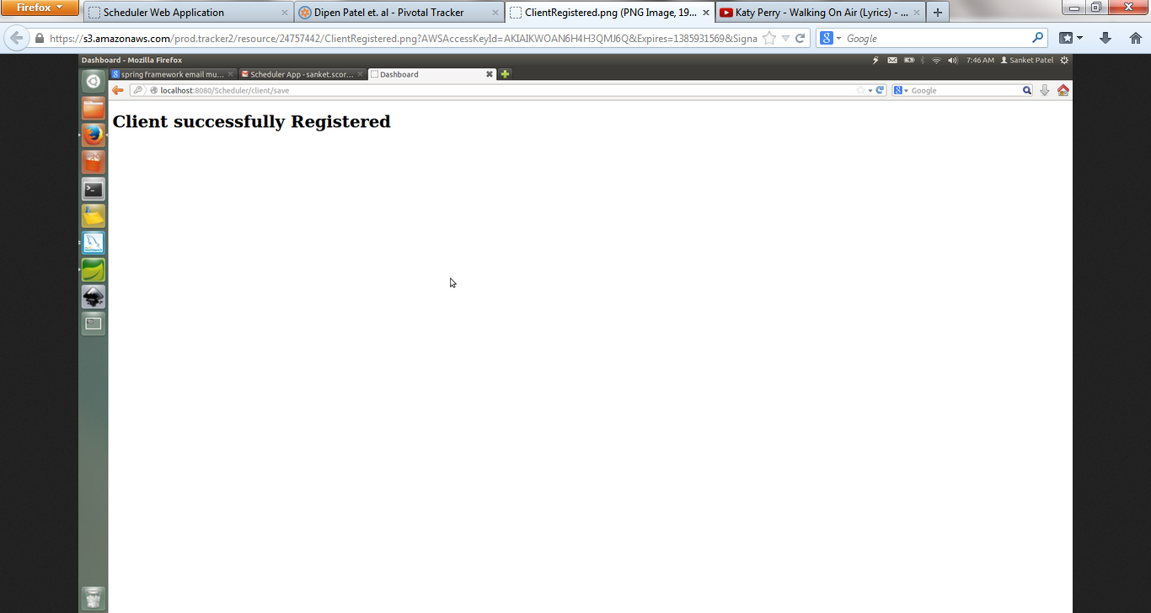

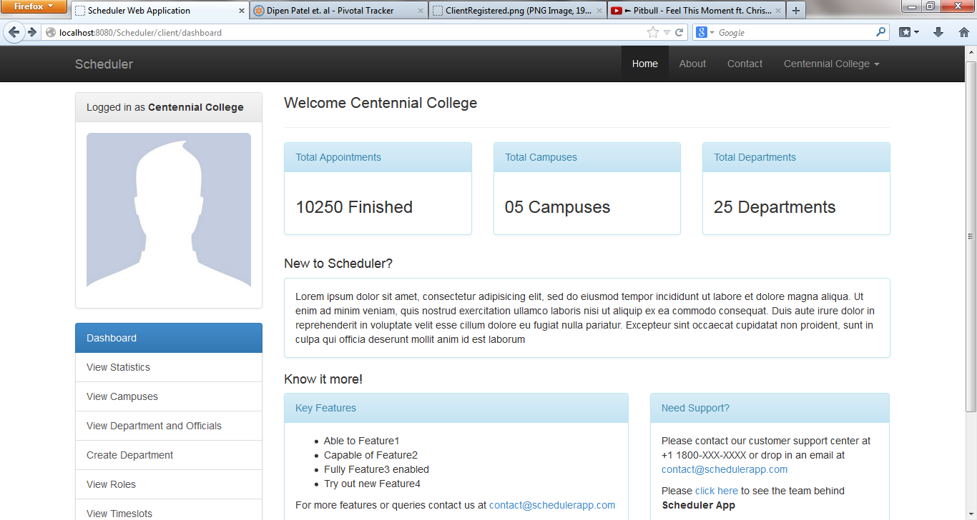

Client's Homepage

Some Important Features

1 – Gives the count of the total number of appointments conducted for each department

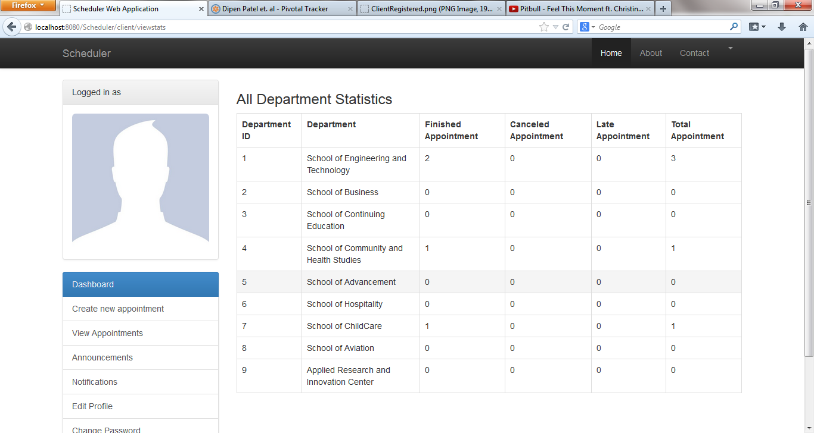

2 – List of campuses for the client

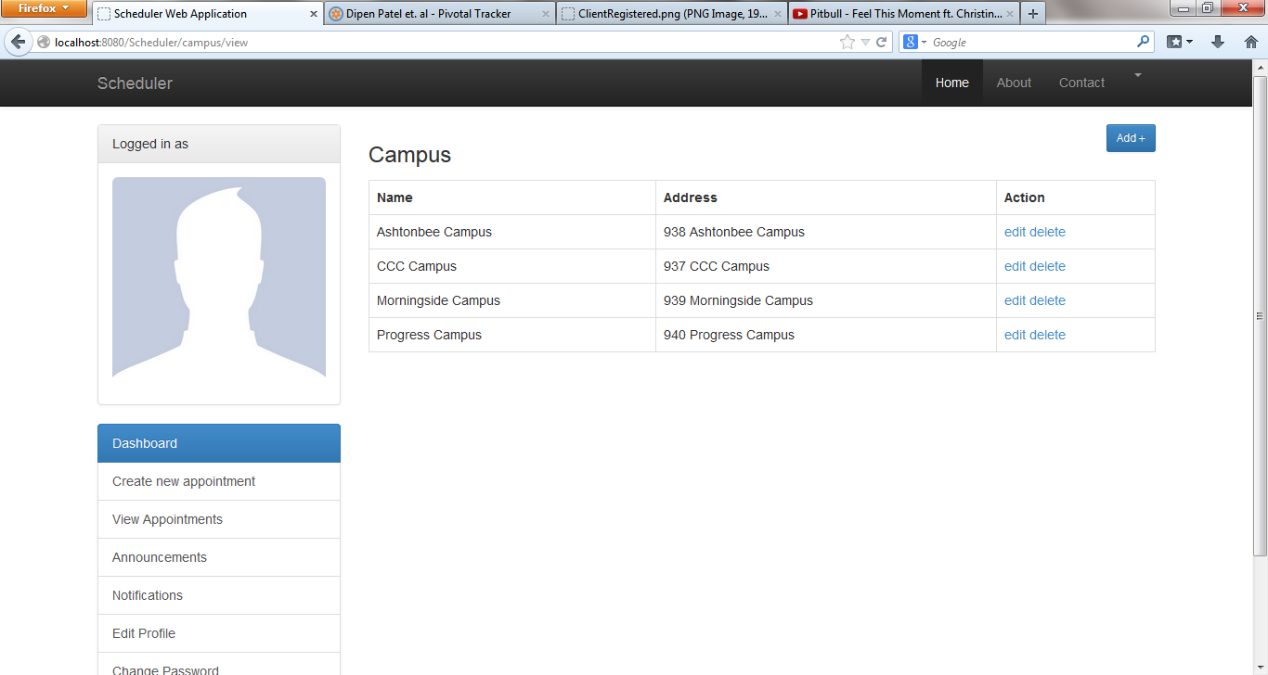

3 – List of all departments and their respective official users

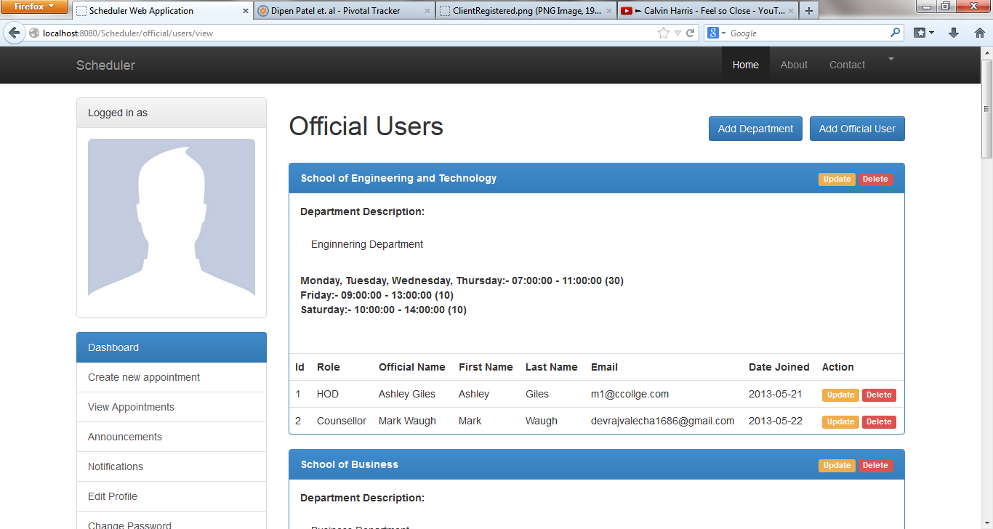

4 – To create a new department

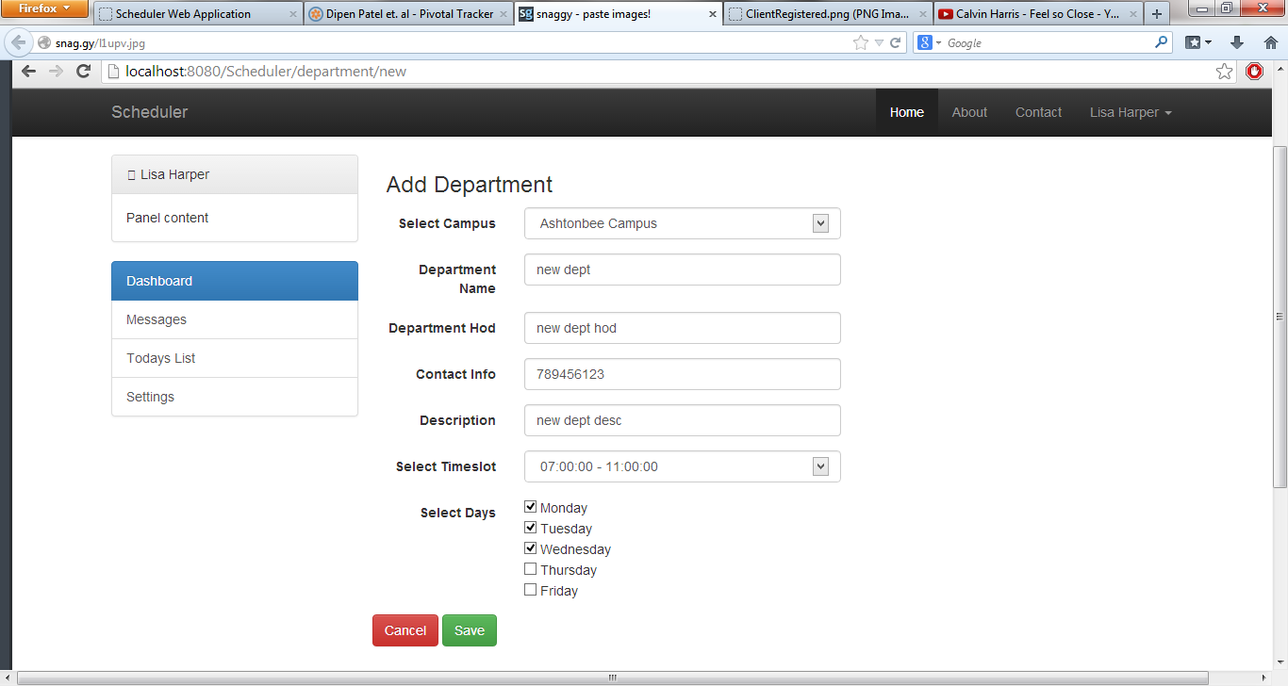

5 – To view roles of official users

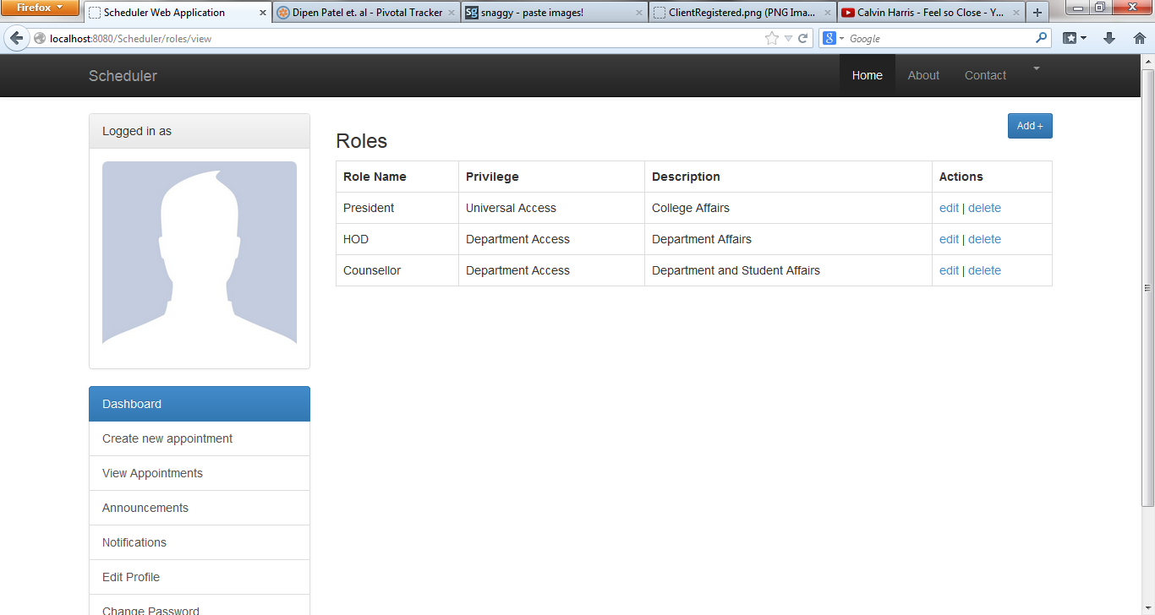

6 – View Time Slots

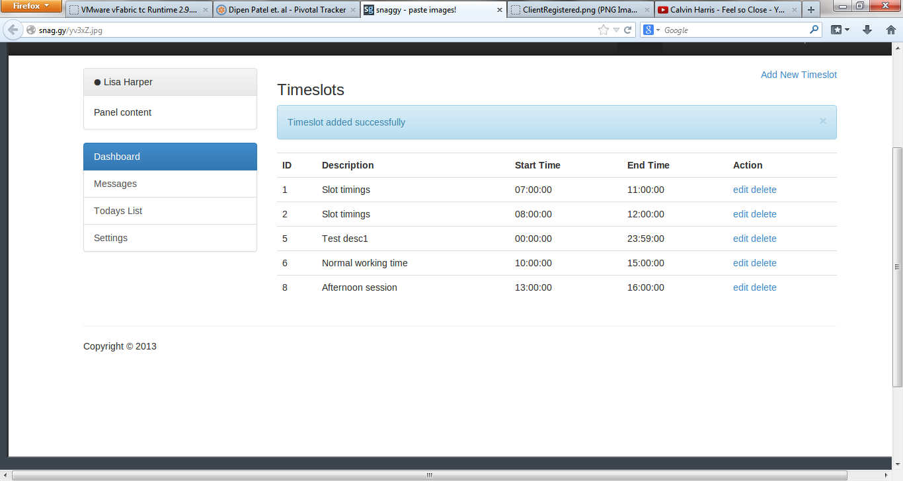

Client Edit Functionality

* 1. Edit Campus

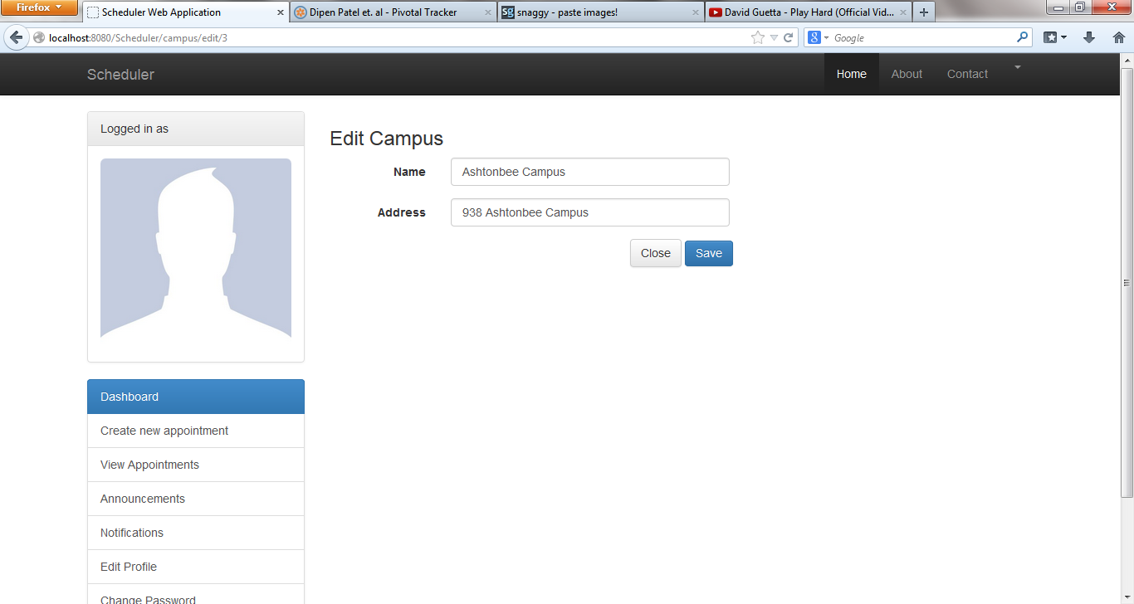

* 1. Delete Campus

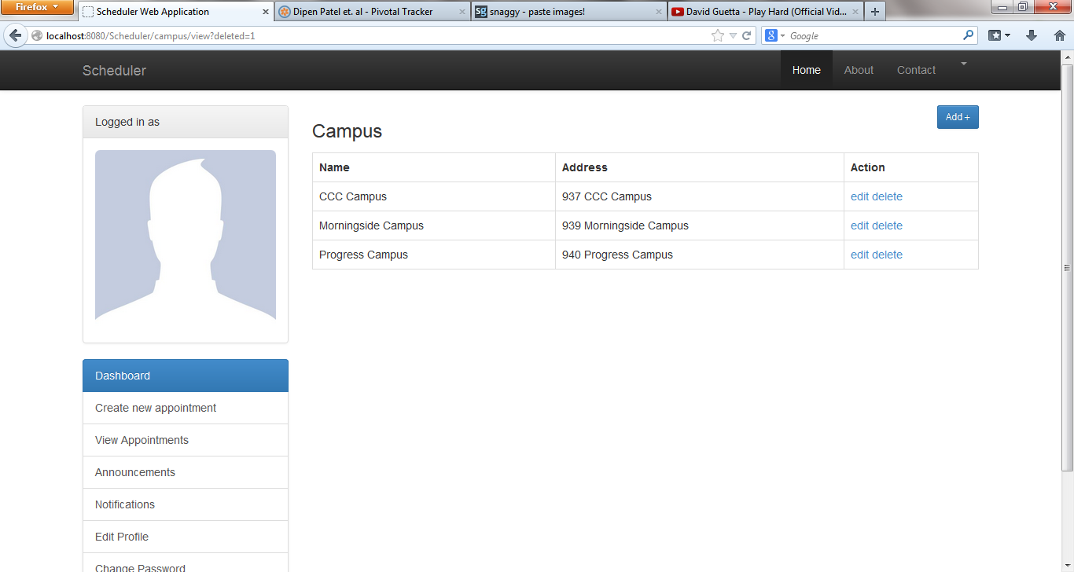

3.1 Edit Department

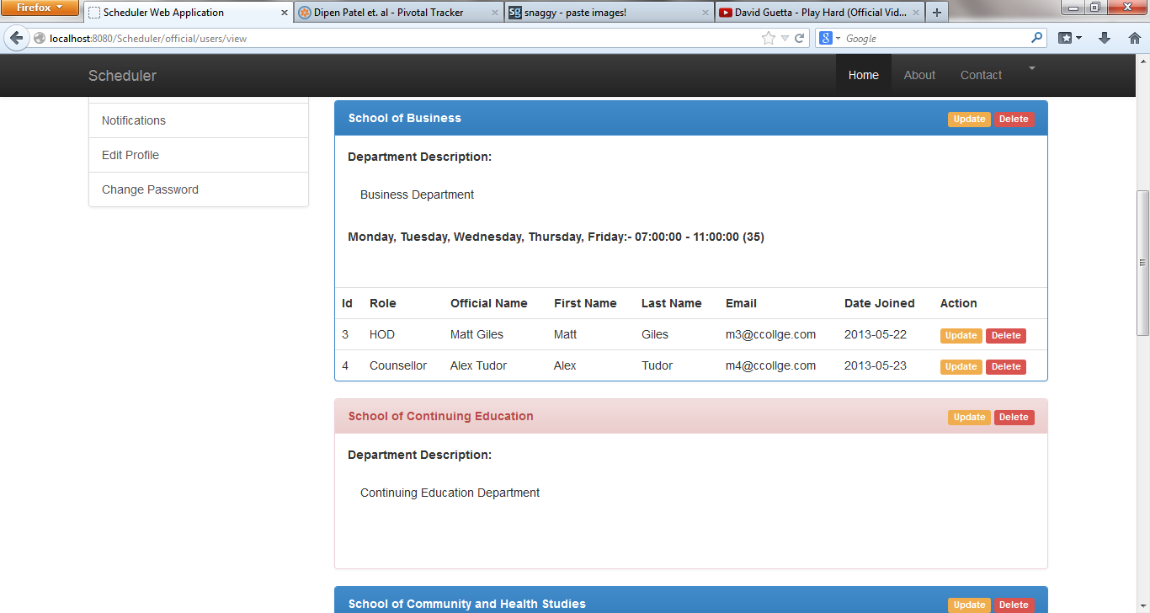

* 1. Delete Department



* 1. Edit Official User



* 1. Delete Official User



* 1. Edit Role

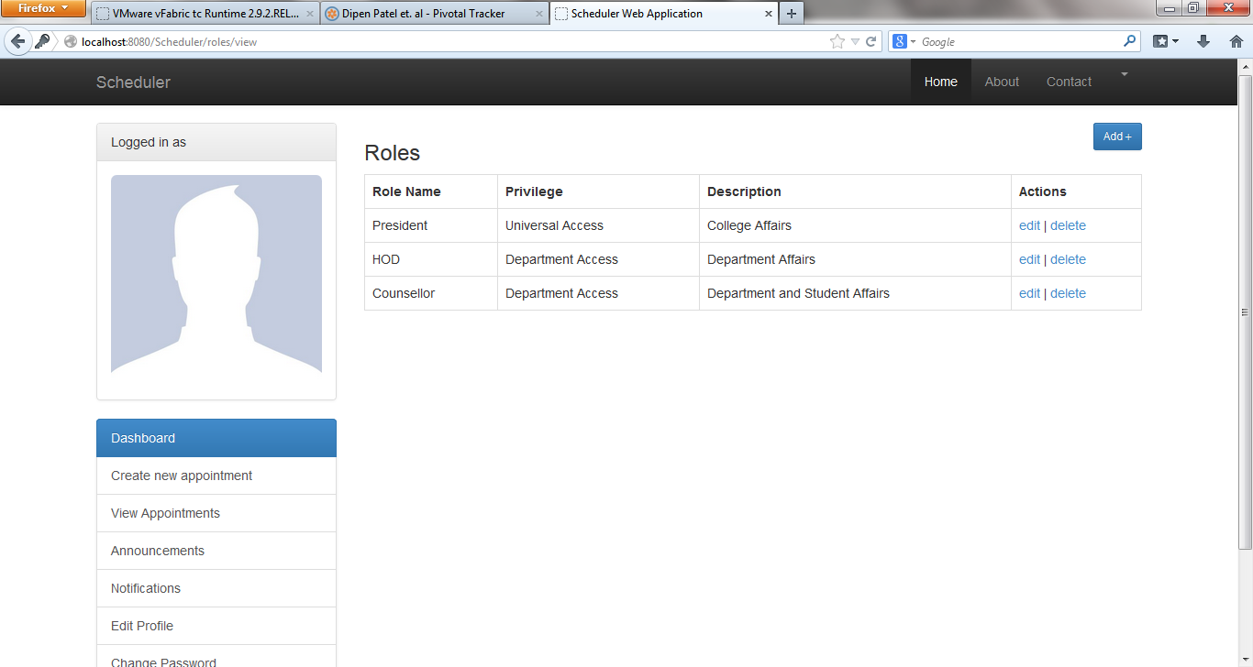

5.2 Delete Role



* 1. Edit Timeslot



* 1. Delete Role



Adding a new general user

1) Click register

2) Input the fields for the user

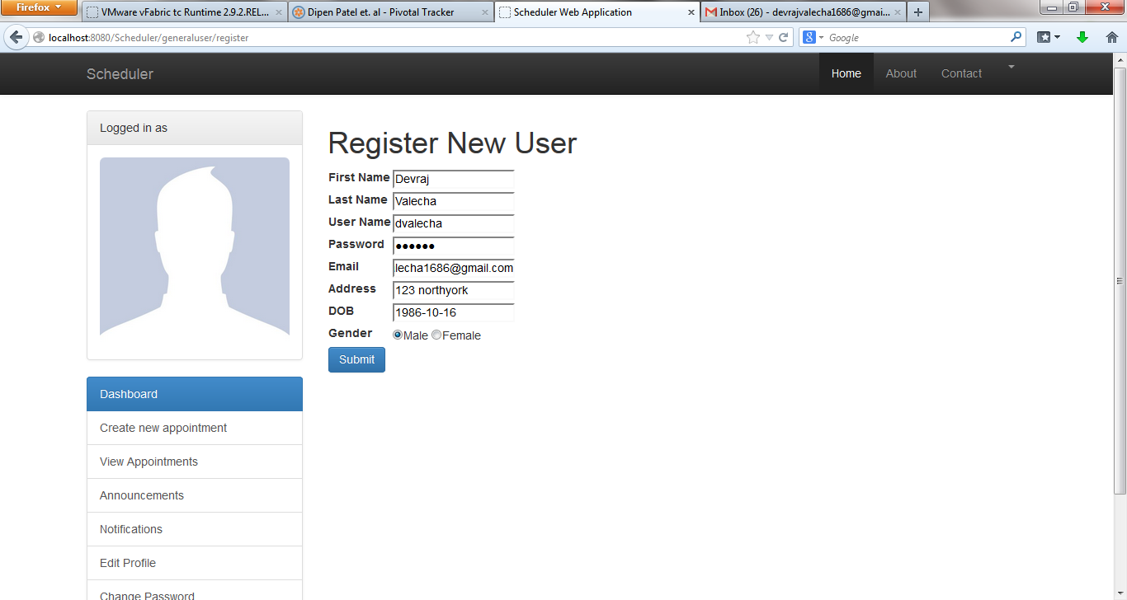

3) Check mail to complete the registration process

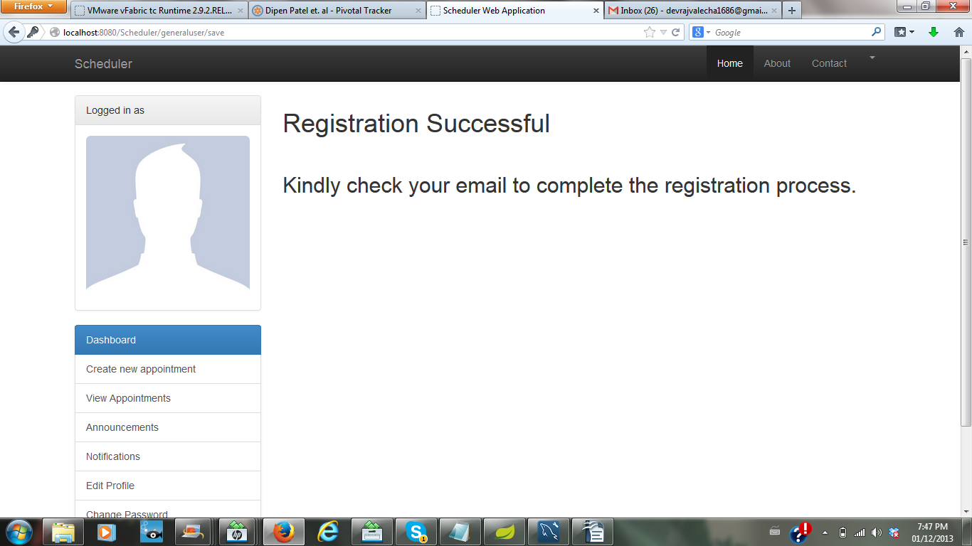

4) Click on the activation link.

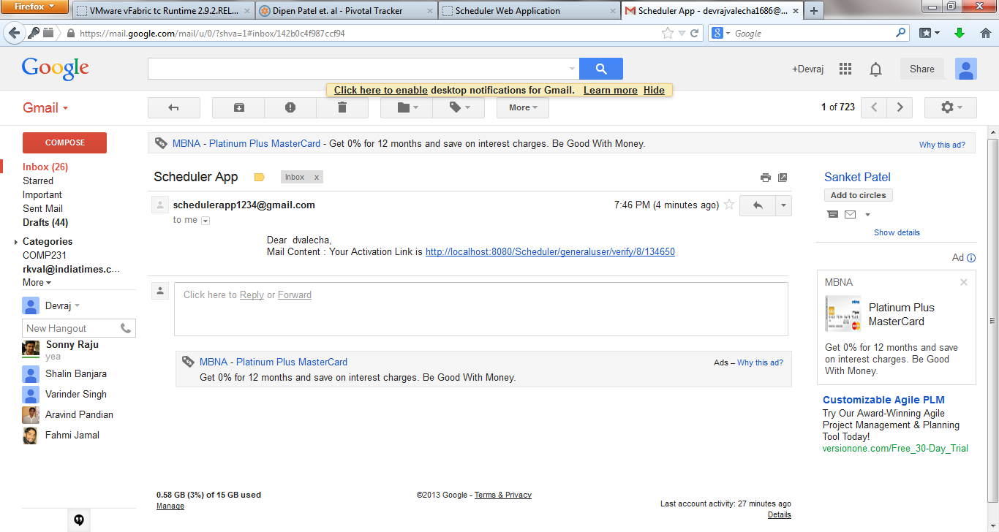

5) Check for the successful verification of email address message

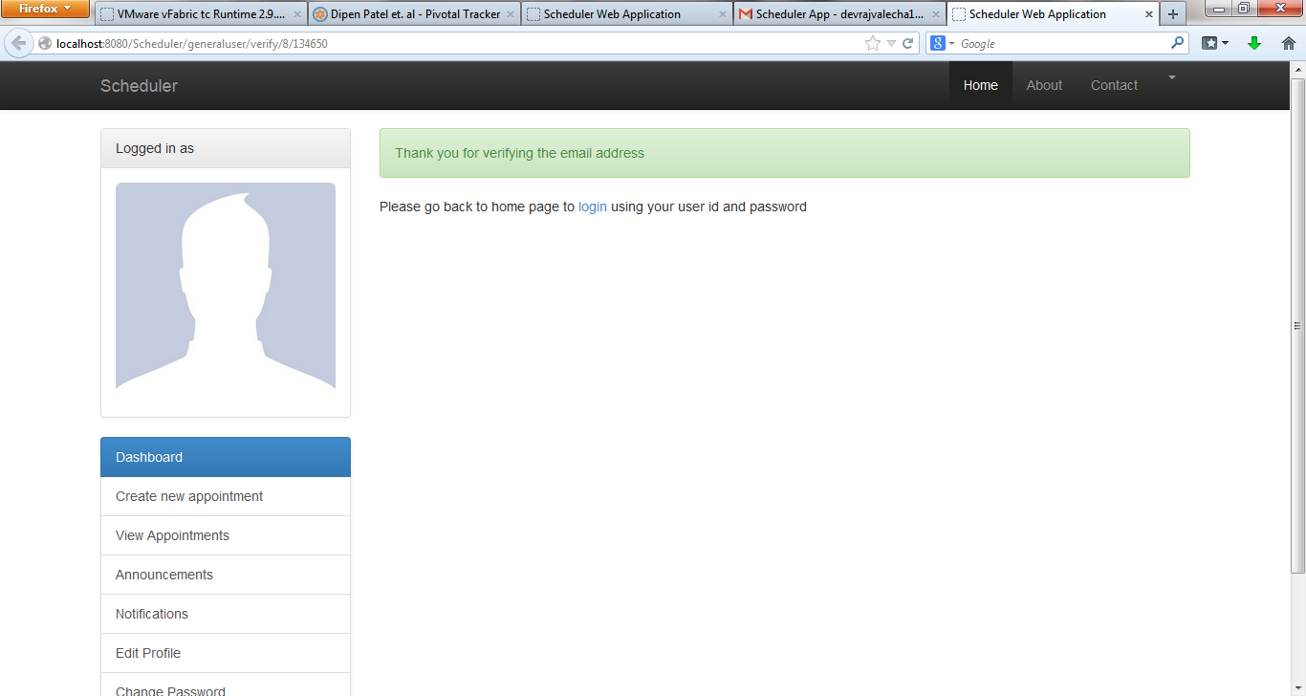

Password Reset

1) Input the email address as was mentioned at the time of registration.

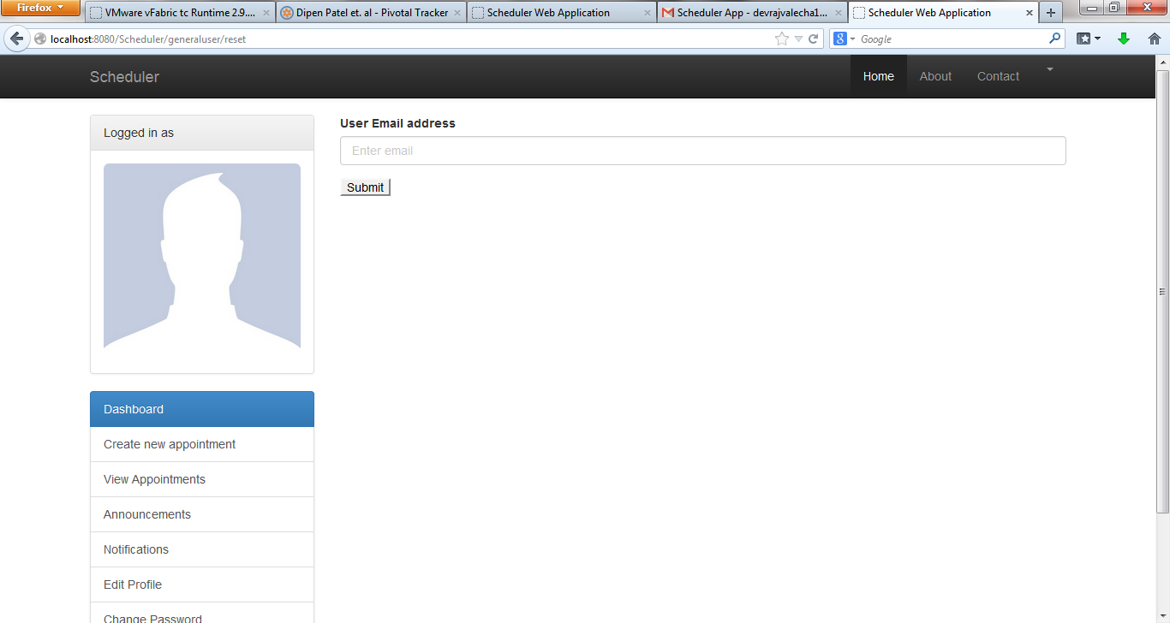

2) Click Submit.



3) After submitting, a temporary password is sent to the email address.

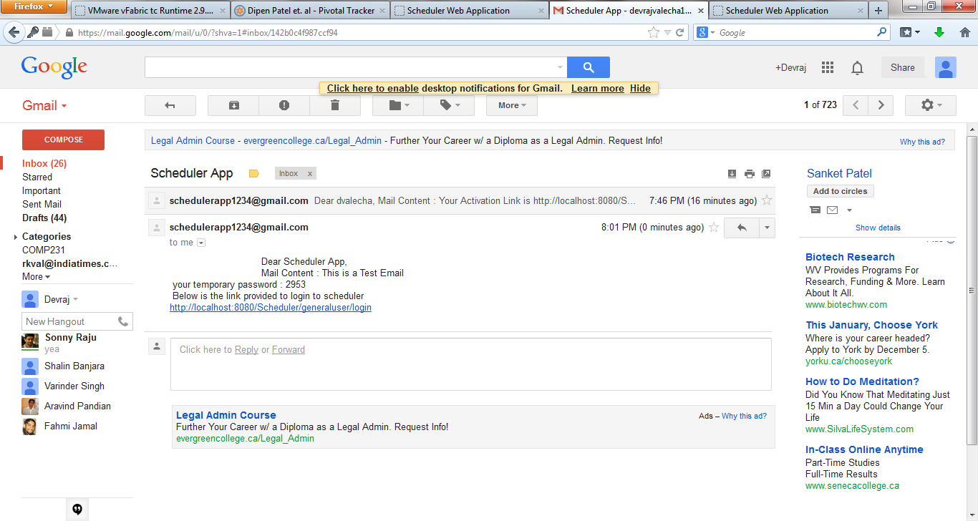

4) Click on the link provided to login to the application using temporary password.

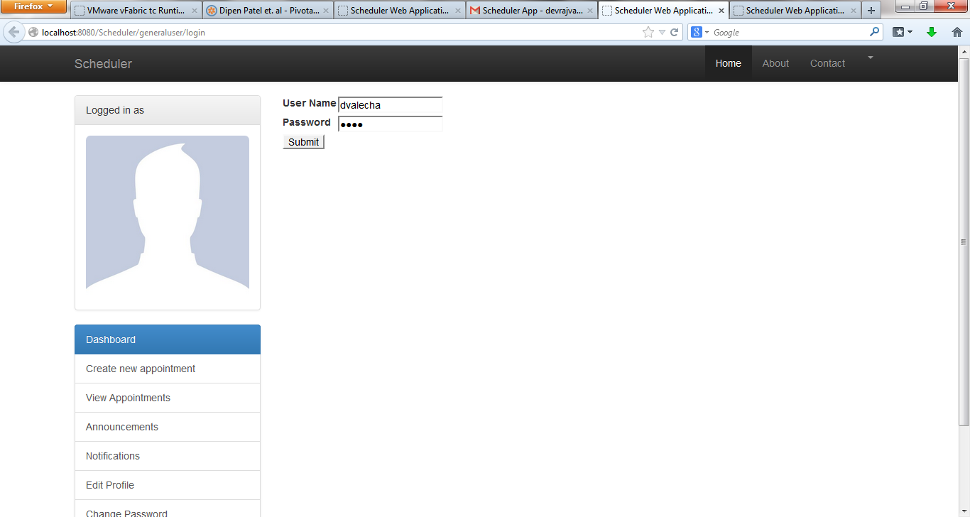

Book an appointment

1) Click book appointment.

1. Input all the mandatory fields

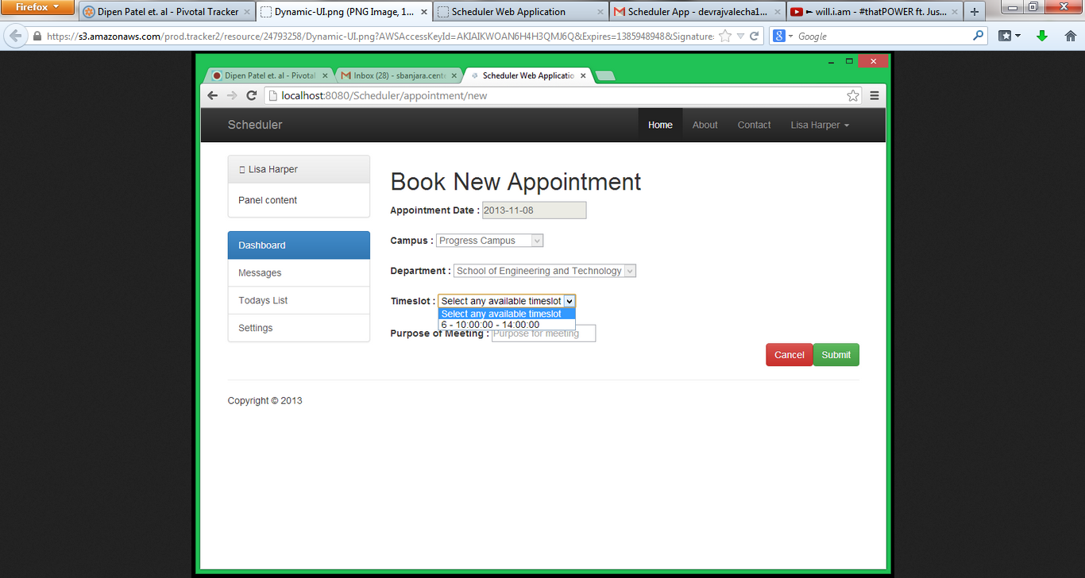

3) Click to submit the appointment.

4) After submitting, the user is able to see the new appointment created on the topmost row.

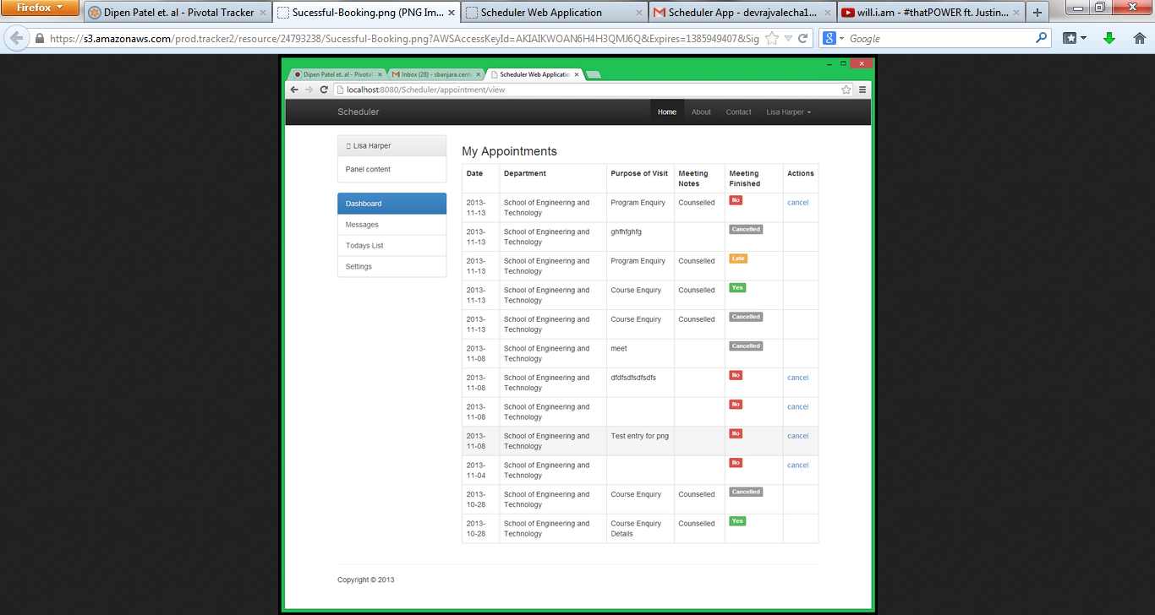

Cancel an appointment

1) Navigate to view appointments page



2) After clicking on cancel, the status changes to 'Cancelled'.



View Notifications

1) Click view notifications

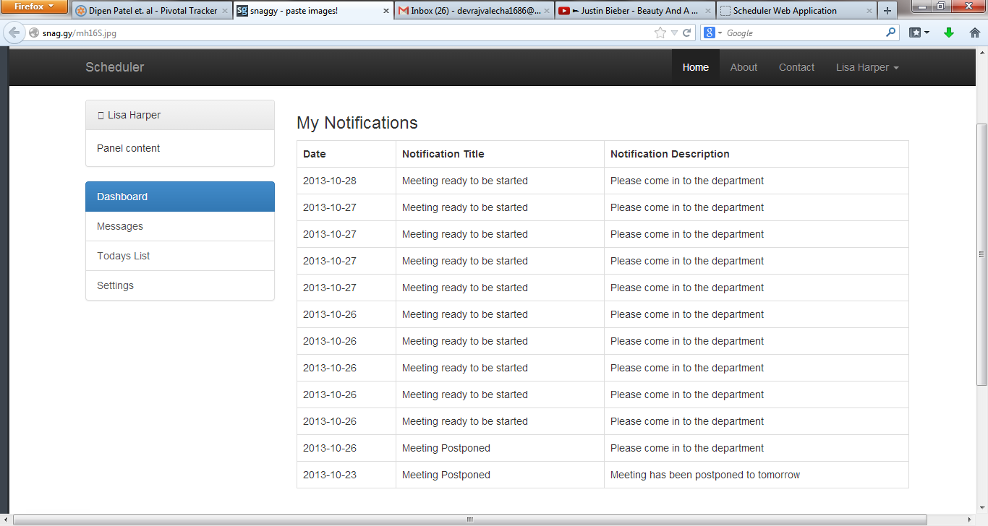

View Announcements

1) Click view announcements.

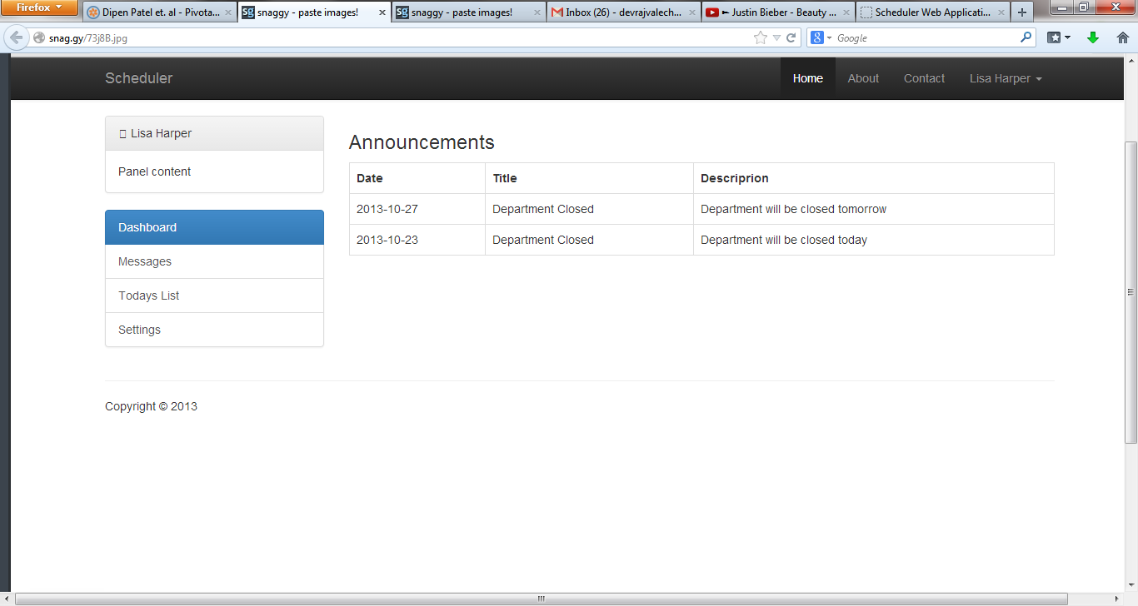

Book Appointment General User [Mobile]

1) Navigate to book appointment page.

2) Input the required data in the fields provided

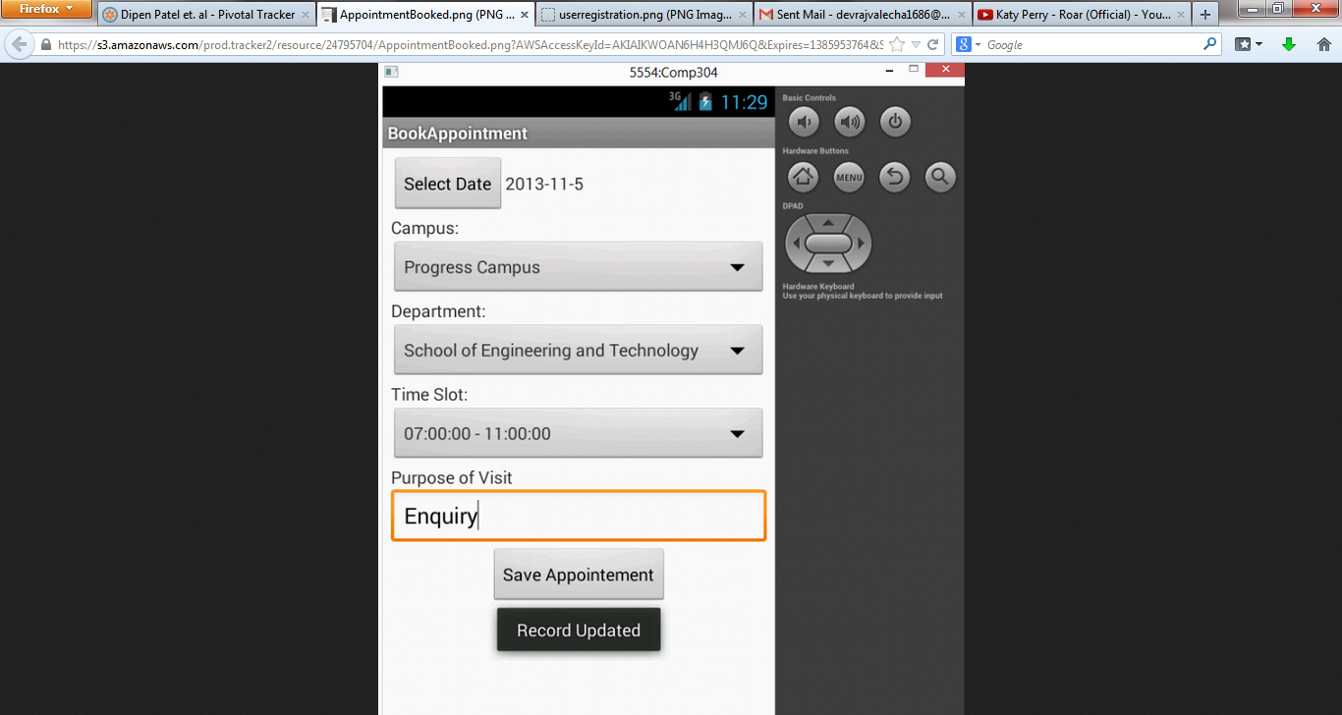

3) Click on save appointment.

View All Appointments [Mobile]

1) Navigate to view all appointments page

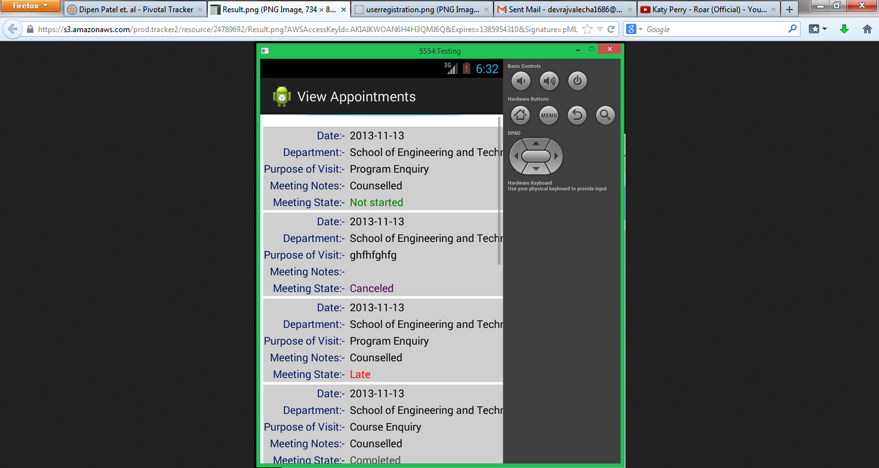

View All Notifications

1) Click on view all notifications.

View All Announcements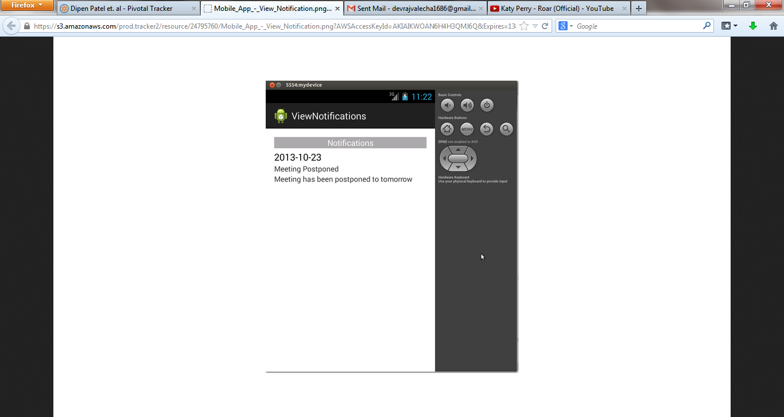

1) Click on view all announcements.

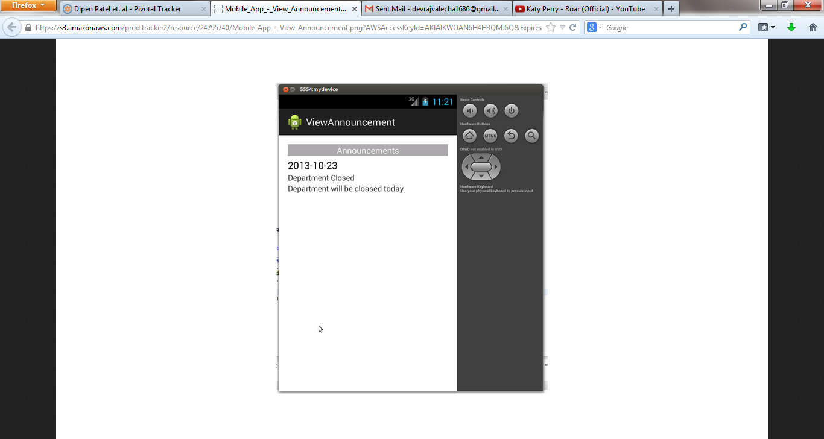

View All Alerts

1) Click on view all alerts to view alerts

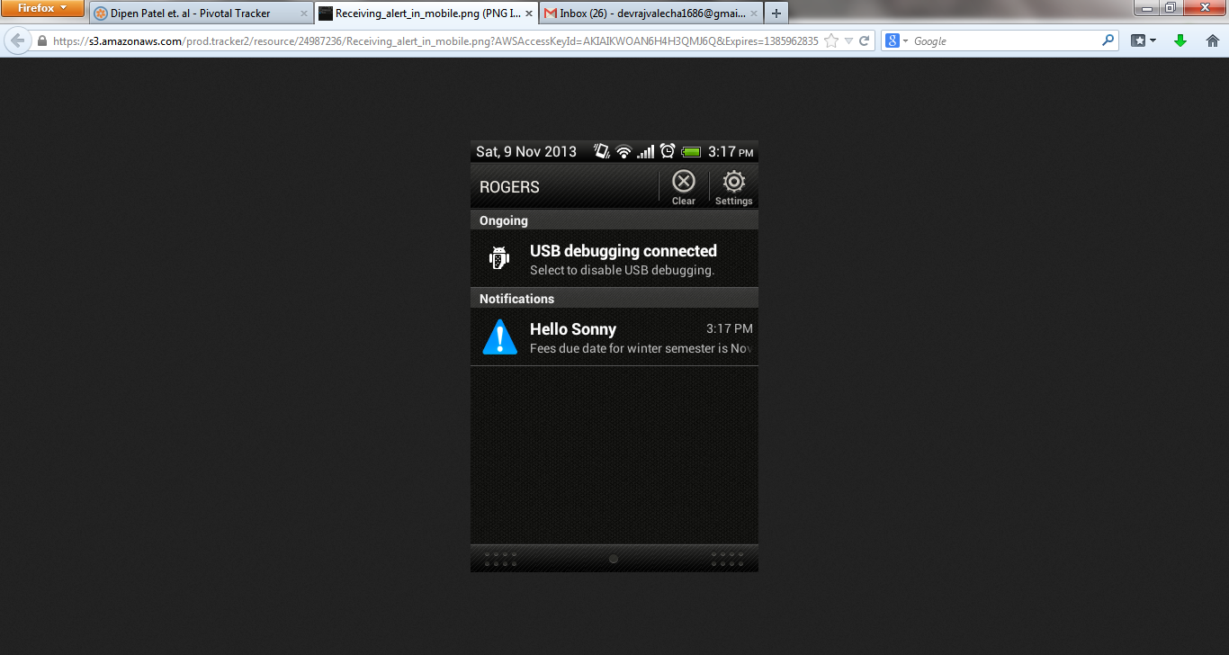

Official User Login

1) Click on Sign In

2) Input the required fields for login

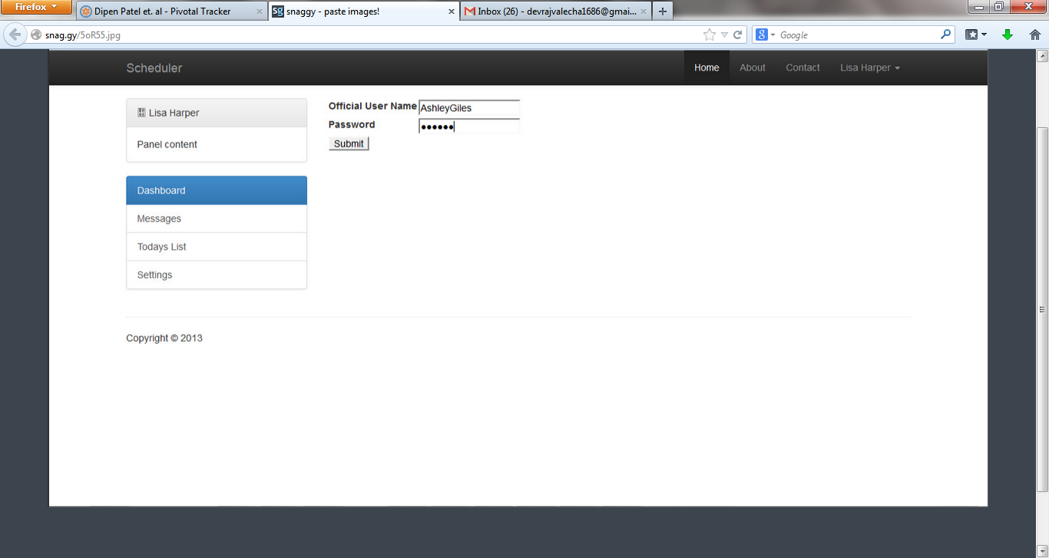

3) Click Submit

Change Password

1) Click Change Password link

2) Input new and confirm password fields

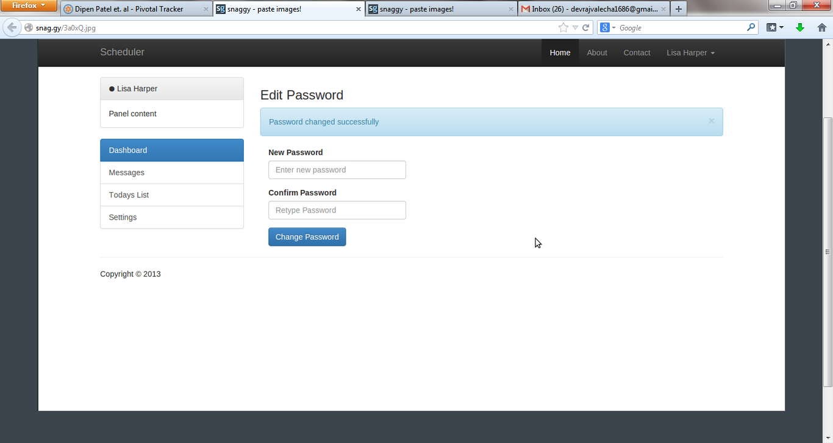

3) Click change password

Send Notifications

1) Click send notifications

2) Input the required fields prior to sending notification.

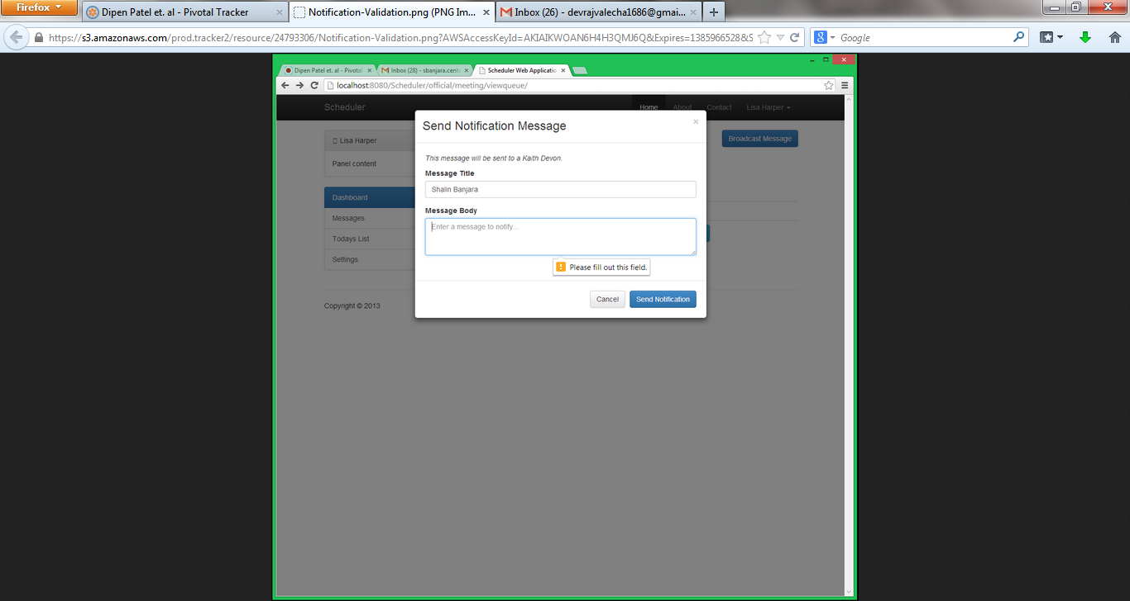

3) Click Send Notification

4) The official user can view the notification in the notification sent list.

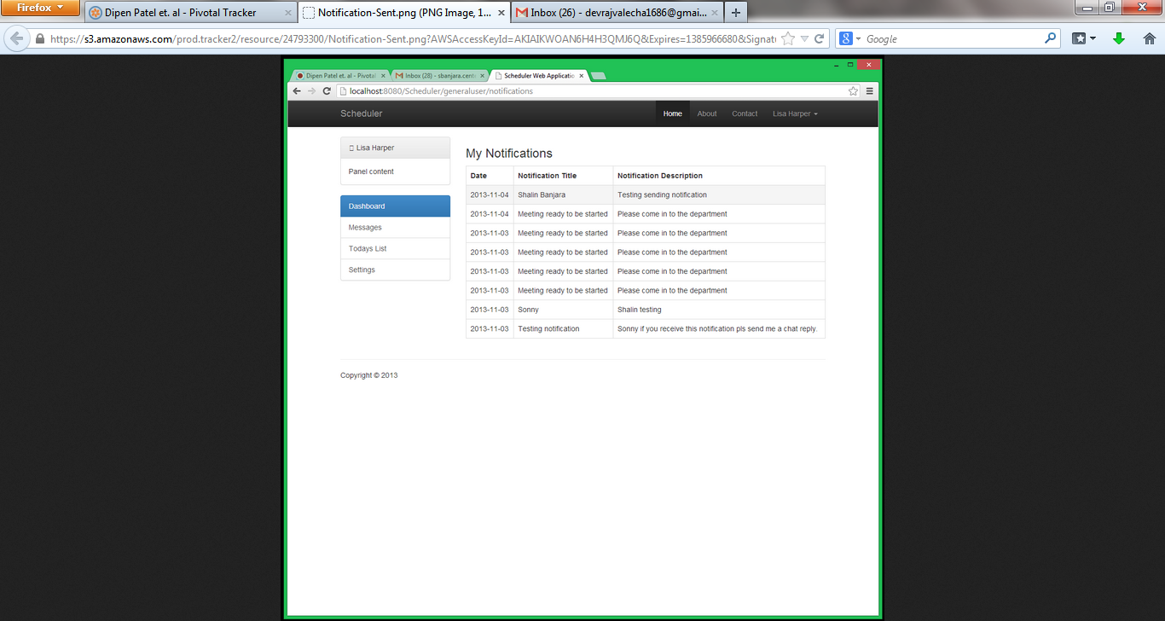

View Appointments

1) Click on view appointments to see the list of appointments in queue.

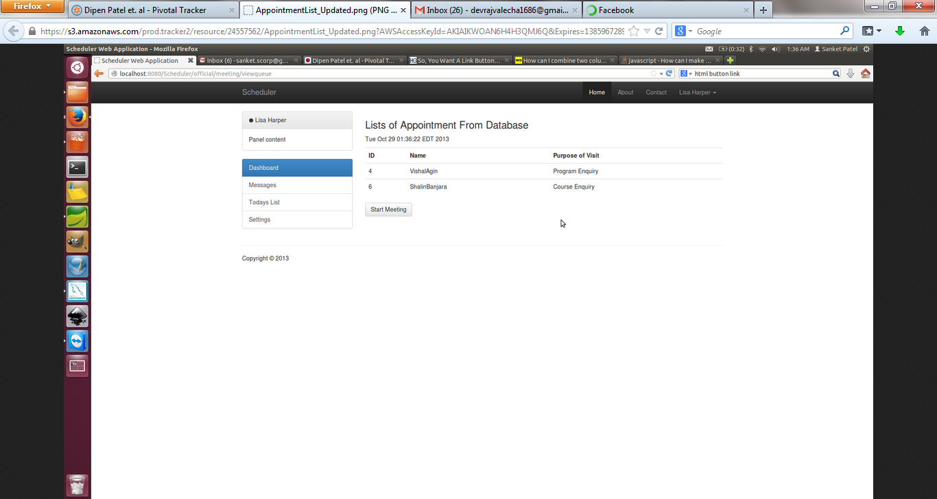Send announcements to all general users in queue

1) Click on send announcement.

2) Input the data in the required fields.

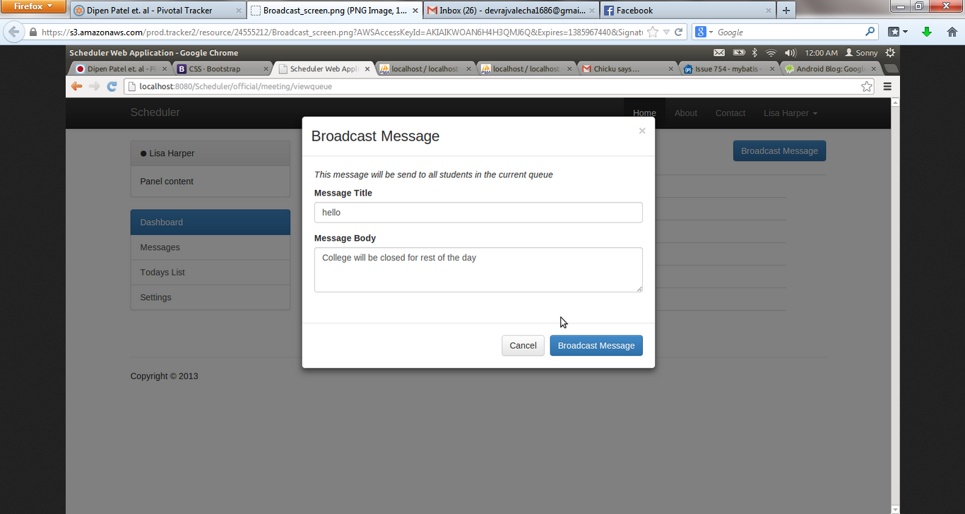

3) Click Broadcast Message

Message Notes

1) Navigate to message notes functionality before/ after meeting.

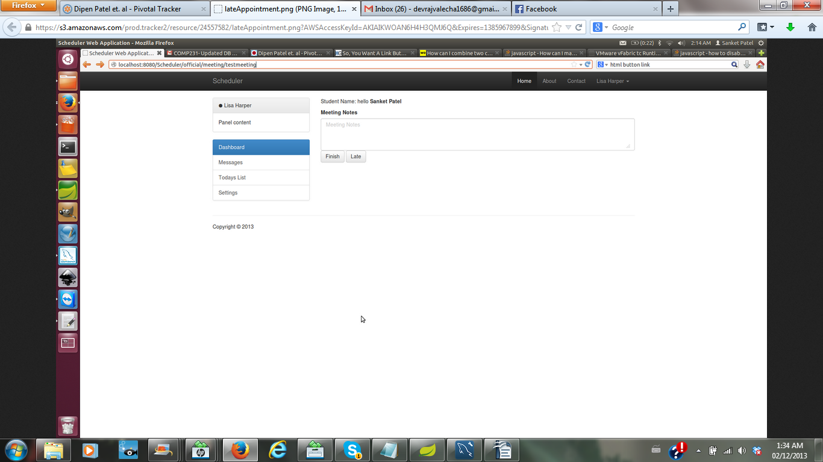

2) If the general user is late, the counsellor can mention in the notes and input the message as 'late'. The late button remains enabled for 5 minutes after the scheduled time.

3) After the meeting is conducted, the counsellor can mention in the notes some important updates that is related to meeting.

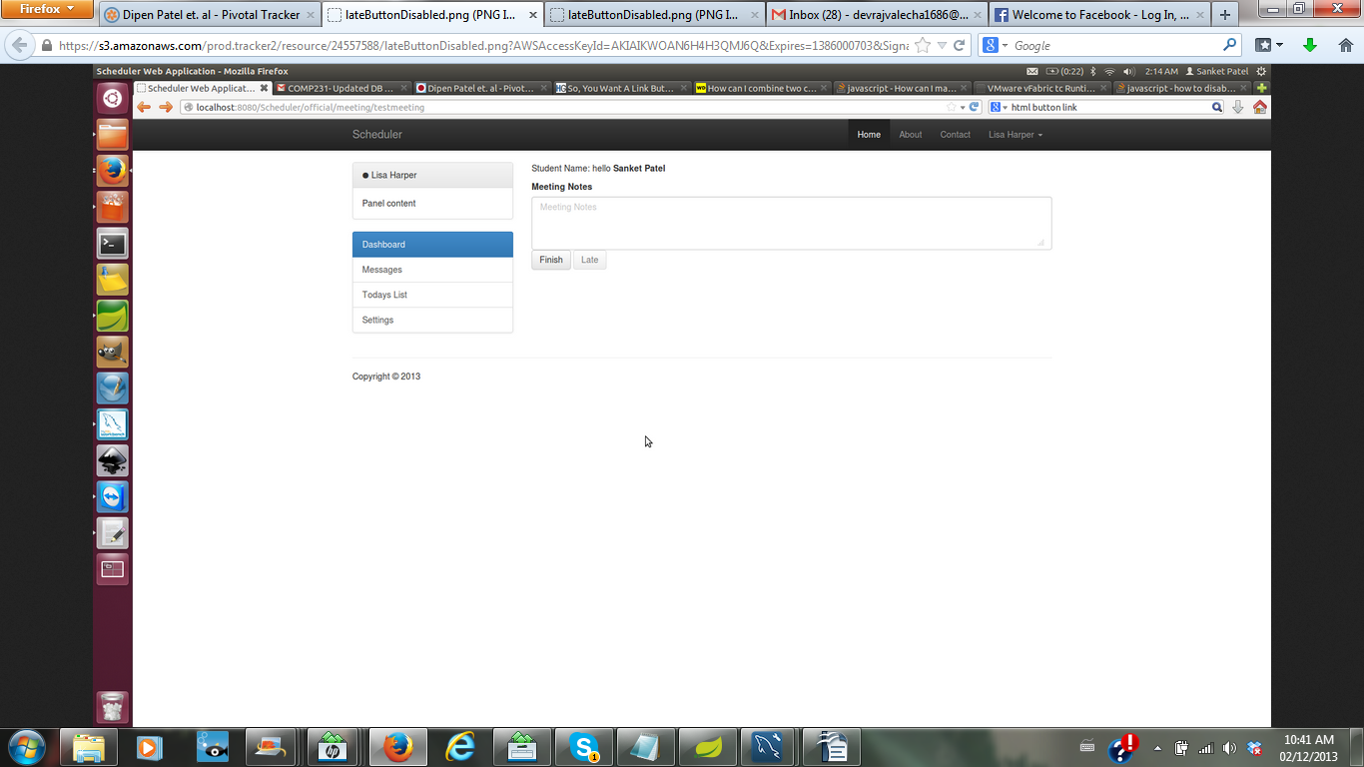 Meeting Start and Finish

1) Click Start button

2) The official user sees the datetime stamp, appointment id, purpose of visit and student name pre-inputted with information.

3) In case of important information about the meeting, meeting notes can be inputted.

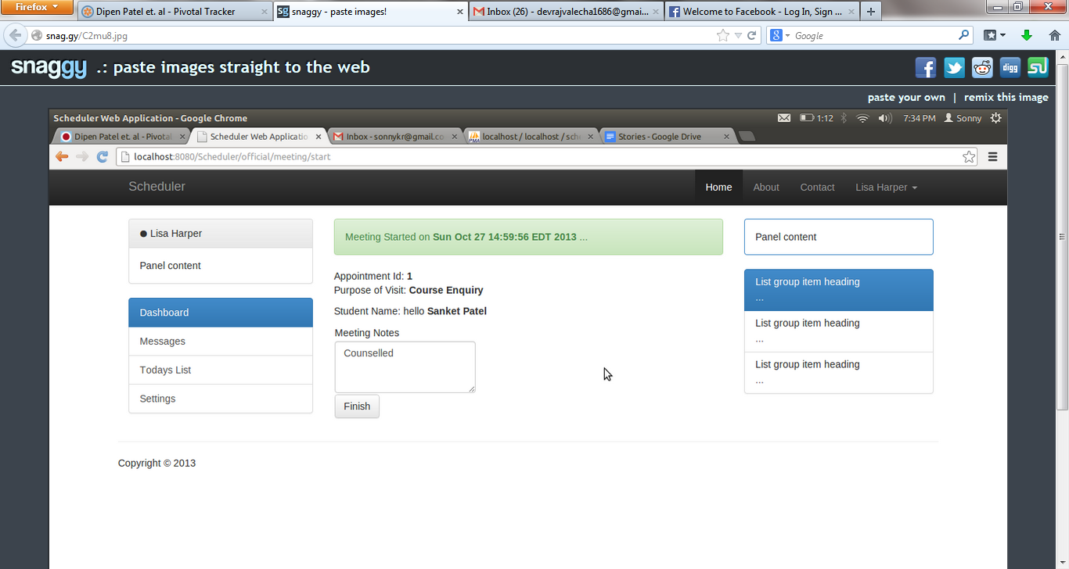

4) Click finish to end the meeting.